|  |  |  |  |  |  |
| --- | --- | --- | --- | --- | --- |
| **No** | **Field Name** | **Data Type** | **Description** | **Constraints** |  |
| 1 |  |  |  |  |  |
| 2 | user_id | INT (PK) | Unique identifier for each user | Auto-increment |  |
| 3 | name | VARCHAR(100) | Full name of the user | NOT NULL |  |
| 4 | email | VARCHAR(255) | User’s email address | UNIQUE, NOT NULL |  |
| 5 | phone_number | VARCHAR(15) | User’s phone number | UNIQUE, NOT NULL |  |
| 6 | password | VARCHAR(255) | Encrypted user password | NOT NULL |  |
| 7 | user_type | ENUM('Passenger', 'Driver', 'Admin') | Type of user | NOT NULL |  |
| 8 | profile_picture | TEXT | URL of the user's profile picture | NULLABLE |  |
| 9 | created_at | TIMESTAMP | Timestamp when the user was created | DEFAULT CURRENT_TIMESTAMP |  |
| 10 | updated_at | TIMESTAMP | Timestamp when the user was last updated | DEFAULT CURRENT_TIMESTAMP ON UPDATE CURRENT_TIMESTAMP |  |

**User Data Dictionary**

**Driver Data Dictionary**

|  |  |  |  |
| --- | --- | --- | --- |
| **Field Name** | **Description** | **Data Type** | **Constraints** |
| driver_id | INT (PK) | Unique identifier for each driver | Auto-increment |
| user_id | INT (FK) | Foreign key reference to Users table | NOT NULL |
| vehicle_id | INT (FK) | Foreign key reference to Vehicles table | NOT NULL |
| license_no | VARCHAR(50) | Driver’s license number | UNIQUE, NOT NULL |
| rating | FLOAT | Average driver rating | DEFAULT 0.0 |
| status | ENUM('Available', 'On Ride', 'Offline') | Driver availability status | DEFAULT 'Offline' |
| created_at | TIMESTAMP | Timestamp when the driver was registered | DEFAULT CURRENT_TIMESTAMP |
| vehicle_id | INT (PK) | Unique identifier for each vehicle | Auto-increment |
| vehicle_type | ENUM('Car', 'Bike', 'Auto', 'Van' | Type of vehicle | NOT NULL |

**Ride Data Dictionary**

|  |  |  |  |
| --- | --- | --- | --- |
| **Field Name** | **Data Type** | **Description** | **Constraints** |
| ride_id | INT (PK) | Unique identifier for each ride | Auto-increment |
| passenger_id | INT (FK) | Foreign key reference to Users table | NOT NULL |
| driver_id | INT (FK) | Foreign key reference to Drivers table | NULLABLE |
| pickup_location | TEXT | Ride pickup location | NOT NULL |
| dropoff_location | TEXT | Ride drop-off location | NOT NULL |
| distance | FLOAT | Distance in kilometers | NOT NULL |
| fare | DECIMAL(10,2) | Total fare amount | NOT NULL |
| status | ENUM('Requested', 'Accepted', 'Completed', 'Cancelled') | Ride status | DEFAULT 'Requested' |
| created_at | TIMESTAMP | Timestamp when the ride request was made | DEFAULT CURRENT_TIMESTAMP |

**Uber Context Level DFD (Level 0)**

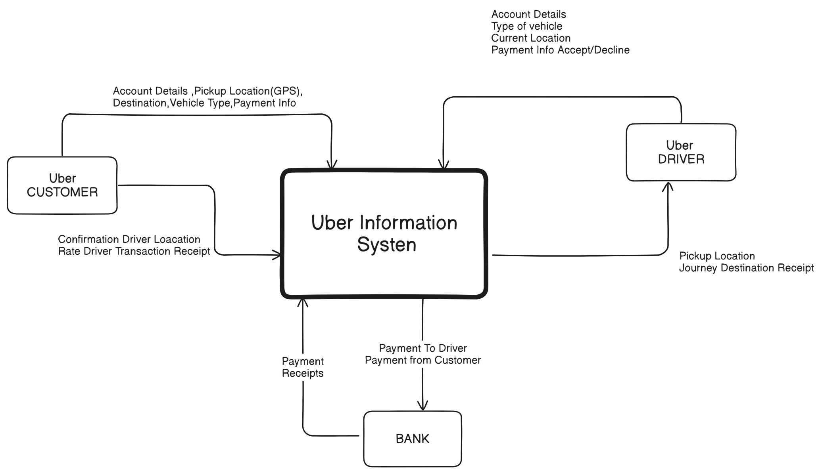

**Uber 1st Level DFD for User & Driver**

